
How to order a custom PCB using kicad and JCLPCB
Advanced Embedded Systems

Authors: Dr. Gilberto Ochoa Ruiz
Msc. Jorge German Perez Blanco
Contents
Introduction 3
Generating Gerber Files in KiCad 6
Annexes 10
Other Resources 10

Introduction
This guide provides a step-by-step overview of how to prepare and submit a printed circuit board (PCB) design for fabrication through JLCPCB using KiCad. It covers the essential stages—from verifying the design rules and generating Gerber files to uploading the final package and placing the manufacturing order. By following these instructions, you can ensure that your PCB design meets the manufacturer’s requirements while maintaining full control over the specifications that best suit your project.

Design and Verify the PCB in KiCad
First, you need to ensure that the design rules are configured according to the manufacturer’s capabilities, while still meeting the specific requirements of your design. To review the specific manufacturing requirements, you can visit the following link:
https://jlcpcb.com/capabilities/pcb-capabilities

You can check and modify your design constraints by the Board Setup menu accessible as shown in the following image:
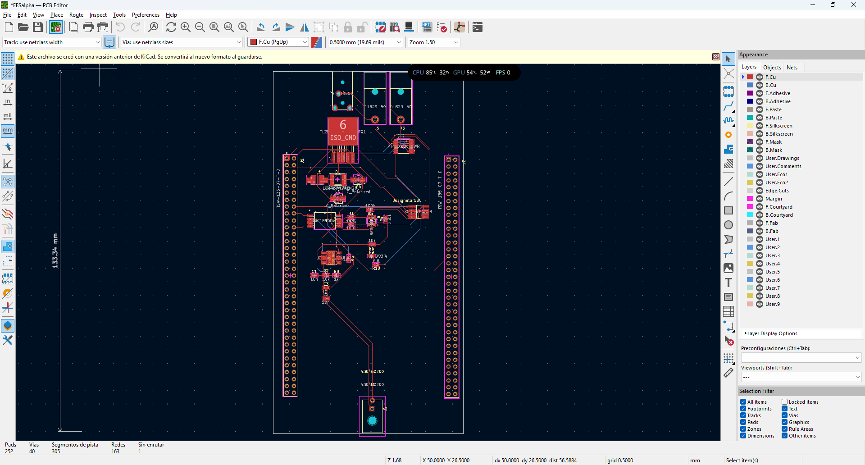

In the Board Setup menu you must select the Constraints section as shown in the following image, and then change settings to match the manufacturers and your own requirements:
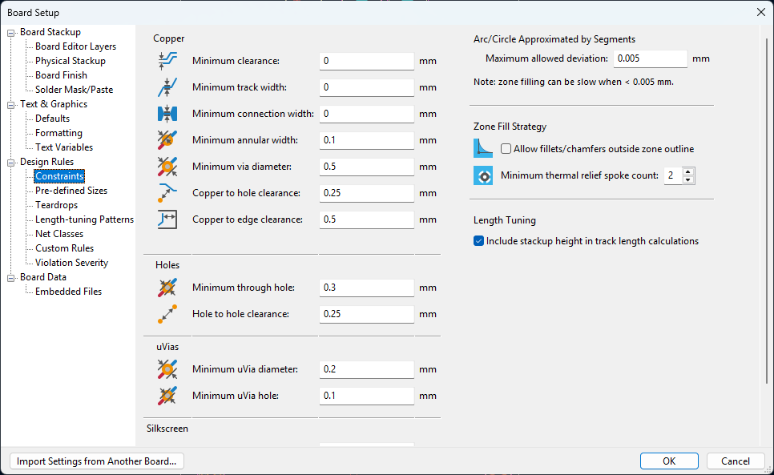
Then you need to run the Design Rule Check (DRC) via PCB Editor → Inspect → Design Rules Checker and fix any reported issues, this will check if your design matches the previously stablished rules.
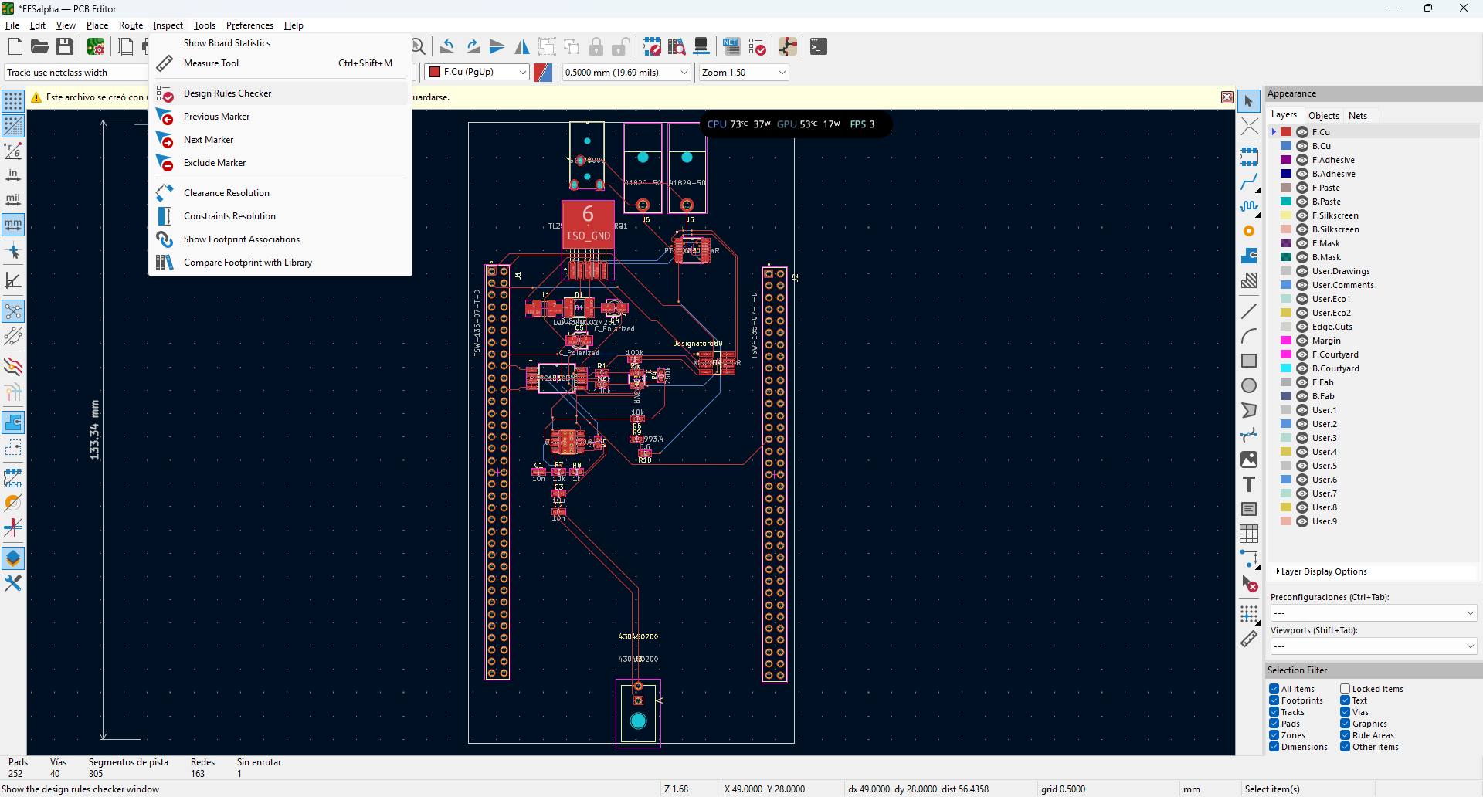
Once you click the previous option the following window will pop up, and you need to click on the Run DRC buttom:
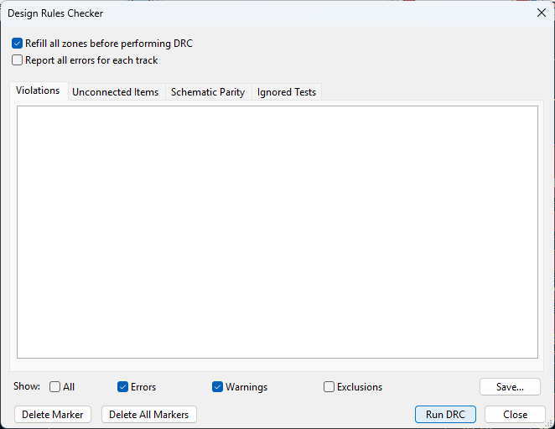
Once you fix all errors you are ready for the next step, warnings can be ignored if you understand what they mean, otherwise ask for help with someone who has more experience.
You can also visually inspect your design via a 3D renderer embedded in the tool, accessible through the button presented in the figure:
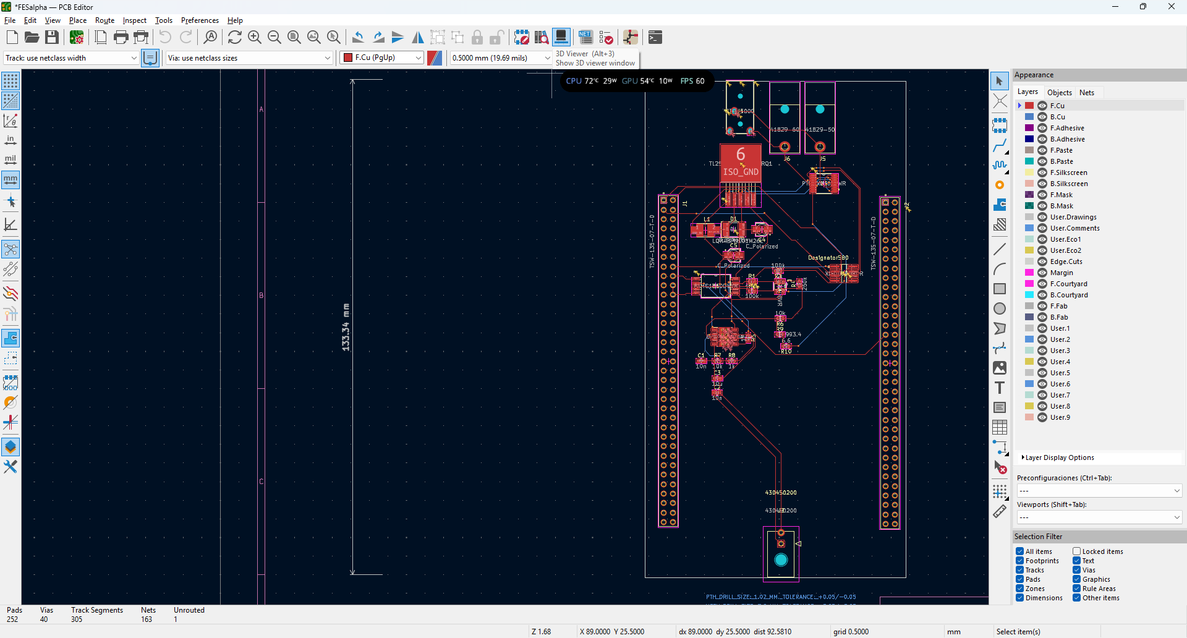
You will see something like this, according to your design, make sure that all silk screen and all the mechanical parts are in the right place:
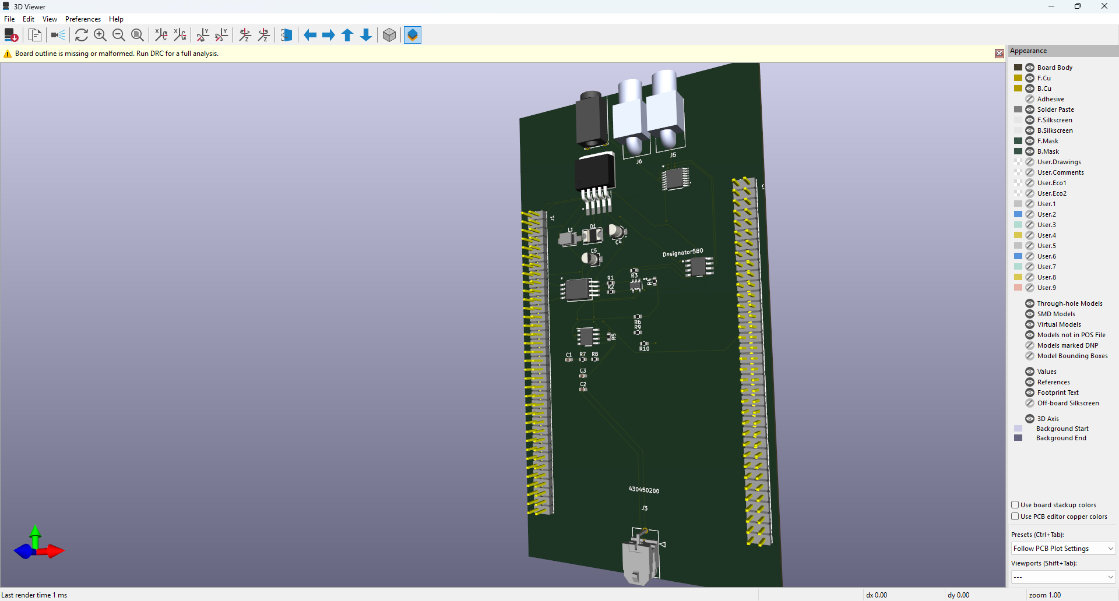

Generating Gerber Files in KiCad
- In the PCB Editor, go to File → Plot...
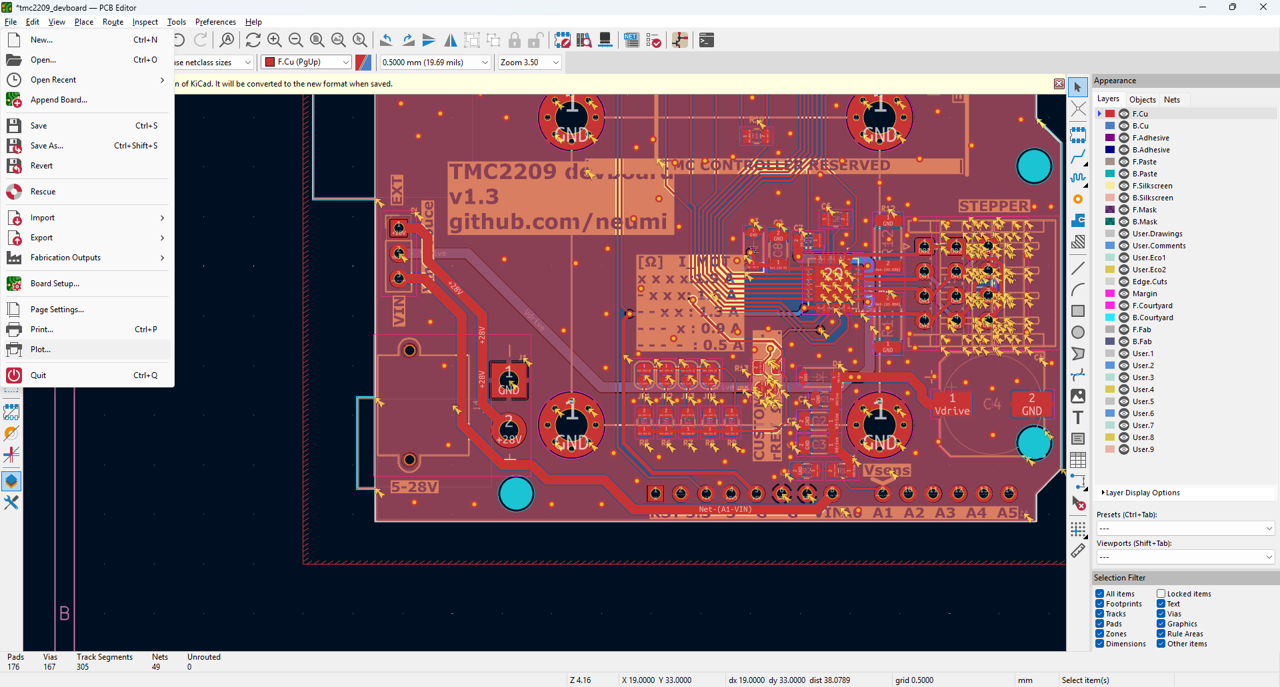
- Configure as follows:
  - Plot format: Gerber
  - Layers to include:
    - F.Cu, B.Cu (copper layers)
    - F.SilkS, B.SilkS (silkscreen)
    - F.Mask, B.Mask (solder mask)
    - Edge.Cuts (board outline)
  - Check the following option:
    - Use Protel filename extensions

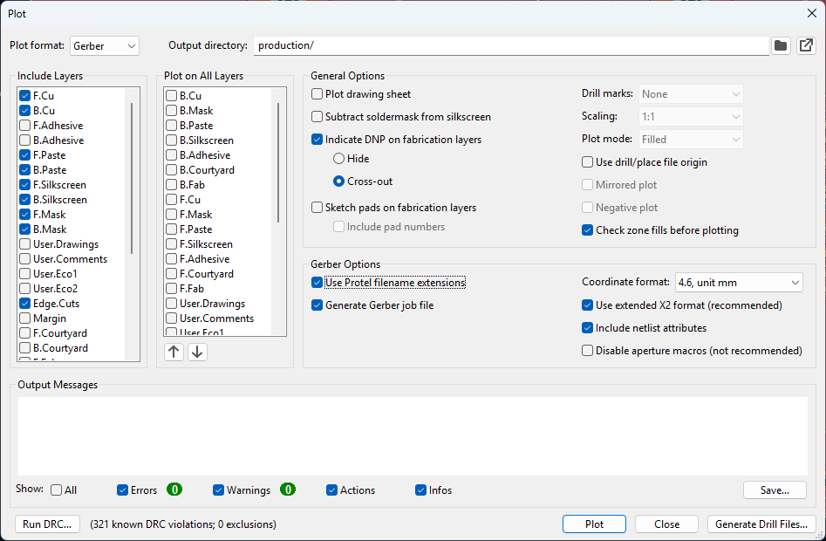
- Click Plot.
- Then click Generate Drill Files:
  - Select metric units (mm).
  - Check Generate Map File.
  - Click Generate.

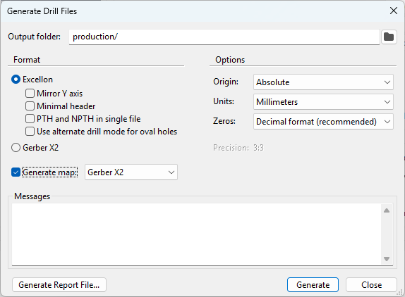
This will produce all Gerber files plus a .drl drill file in your project folder.

Package the Project
- Open the folder containing the generated files.
- Select all Gerber files and the .drl drill file.
- Compress them into a ZIP archive — this will be uploaded to JLCPCB.
Example: MyProject_PCB_Gerbers.zip

Upload to JLCPCB
- Go to https://jlcpcb.com/
- Create an account or sign in.
- Upload your ZIP file with the Gerber files.
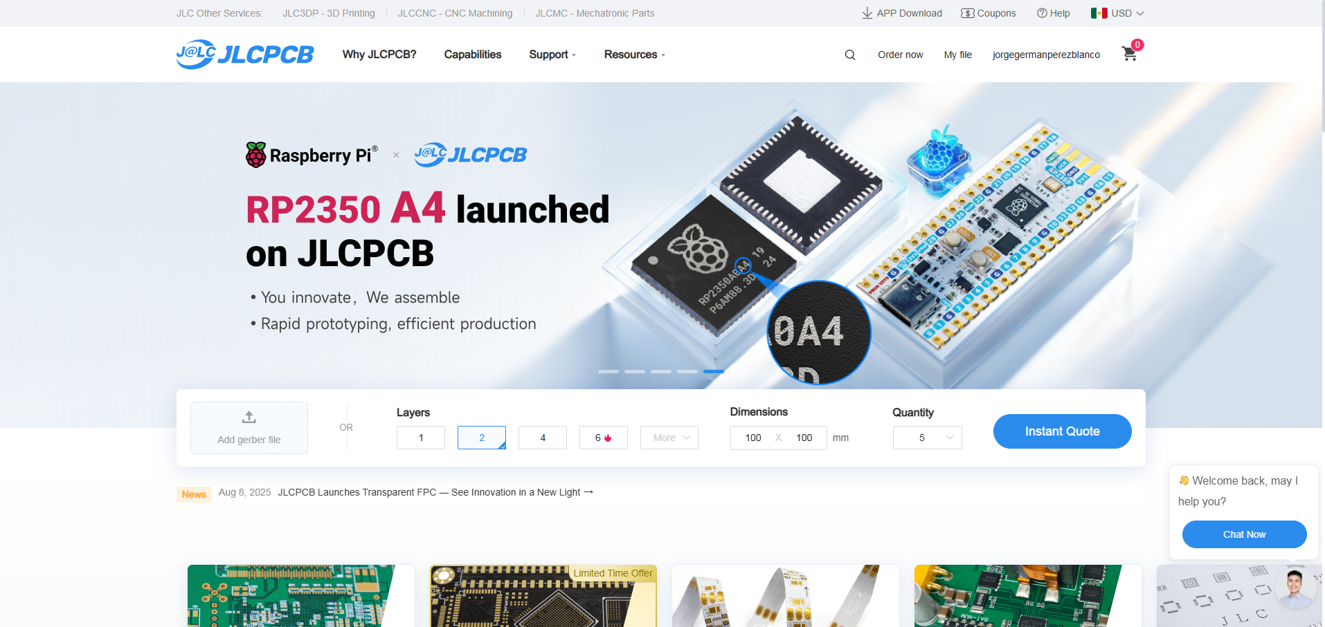
- Wait a few seconds while JLCPCB loads a preview of your board.
- Verify board dimensions, layer count, and silkscreen text.
- Configure the PCB manufacturing options:
- Base Material: FR-4
- Layers: 1 or 2 (depending on your design)
- Thickness: 1.6 mm (standard)
- Copper Weight: 1 oz
- Solder Mask Color: Green (or any you prefer)
- Surface Finish: HASL with lead / lead-free
- Panelization: No (unless you need it)
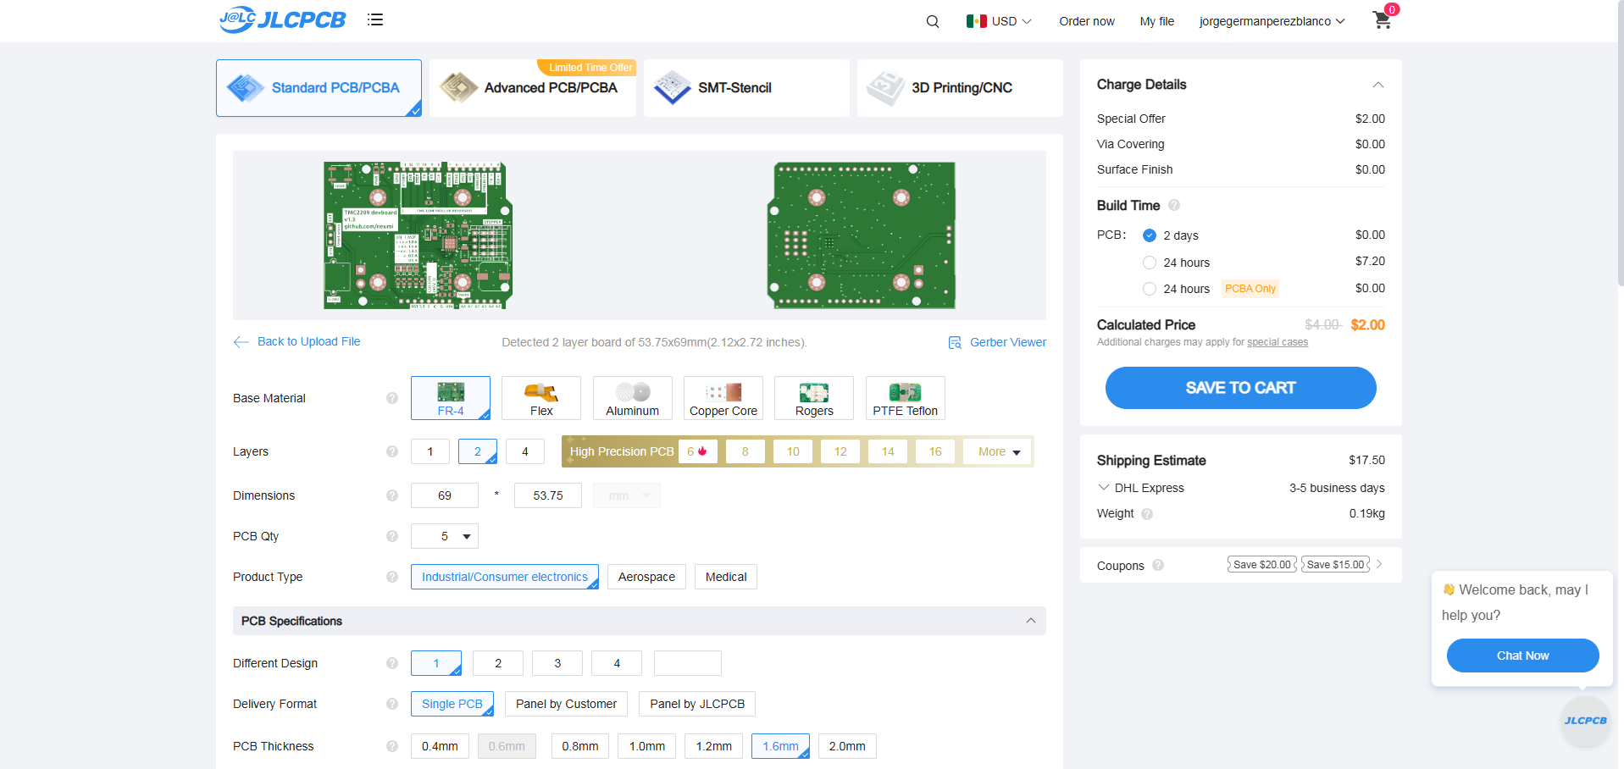
- Review the total cost — usually inexpensive for 5 or 10 boards.

Checkout and Shipping
- Click “Save to Cart” → “Checkout Securely.”
- Choose a shipping method (DHL, FedEx, etc.).
- Pay with credit card or PayPal.
- You’ll receive an email confirmation and tracking number once fabrication begins.
Order Tracking and Delivery
- Track your order from the “Orders” section of your JLCPCB account.
- Fabrication usually takes 1–2 days, and shipping 3–5 days, depending on location.
Final Tips
- Before uploading, review your design with the KiCad Gerber Viewer or JLCPCB’s online viewer to confirm all details.
- If you also want JLCPCB to assemble components (SMT Assembly), you’ll need to generate:
  - BOM.csv (Bill of Materials)
  - CPL.csv (Component Placement List)
  - and follow their SMT Assembly ordering process on the website.

Annexes

Other Resources
https://www.youtube.com/watch?v=RkhuAnc5-zI
https://www.youtube.com/watch?v=v9FglN80EMM

